 | EMC2 | Documentum | Phone: (416) 507-2835  E-mail: roth_michael@emc.com
Integrating netegrity Siteminder with WDK applications

Table of Contents

Introduction 2
An overview of Netegrity Siteminder 2
A Typical Use Case Scenario 3
Current Integration Issues with Reverse Proxies 3
Installation of Netegrity 4
Pre-Requisites 5
Installing the Policy Server 5
Configuring the Policy Server 8
Launching the Policy Server administrative interface 8
Configure an Agent Object 10
Configure a “Host Configuration” Object 11
Create an “Agent Conf” Object 12
Protecting the Application 13
Create a User Directory 13
Create a Domain 14
Create a Realm 15
Create a Rule 15
Create a Policy 16
Final Steps 17
Installing and configuring the web agents 18
Running the Web Agent Installer 18
Configuring Web Agents – WA Configuration program 18
Enabling the Web Agent 19
To Enable the Web Agent 19
Modifying the httpd.conf File 19
IMPORTANT - Tuning Shared Memory on Solaris or HP-UX Systems 21
Configuring Documentum to use Siteminder 22
Configuring WDK Applications 22
Configuring the Repository 22
Troubleshooting 24
Logging 24
Content Server Logging & the Login Sequence 24
Web Agent logging 24
Policy Server Logging 27
Other Resources 27

Introduction

The purpose of this document is to provide an overview of Netegrity SiteMinder as well as its implementation and integration with the current (5.3 SP1) versions of Documentum’s WDK applications.

An overview of Netegrity Siteminder

SiteMinder is a tool that provides seamless single sign on capabilities (SSO) to web applications. Once a user has been authenticated with a Netegrity server they will not need to enter their credentials when accessing any resources that are protected by that server. This means that should a user log into a server when accessing the corporate portal, they will not have to re-enter their credentials if they then decided to access the companies WebTop application; even if that application is running on another web server so long as that the WebTop application is protected by the same SiteMinder server.

A typical SiteMinder deployment would look like as follows:

Web Server
SiteMinder Web Agent
Policy Server
User Source
The main components involved are:

Web Server: This is one of a number of web servers that are supported by Netegrity. The web server will typically act as a reverse proxy for an application server
SM Web Agent: This is shipped as a plug in for one of the supported web severs (see below) which is responsible for the authentication of users to protected resources on the web server.
Policy Server: The SM Policy Server specifies the rules for determining protected resources as well as which users/groups have permissions to access these resources
User Source: The user source is some form of registry for user accounting. This is either an LDAP/X.500 server or an Active Directory.

A Typical Use Case Scenario

Normally, when a user tries to access a protected web site, they will be prompted for a username and password. These credentials a passed off to the Agent on the web server which will communicate with the policy server. The policy server will first authenticate the user against the user source, then compare the user and his/her permissions with the rules set up for the resource that is being accessed (some users my only be able to perform GET actions, others POST and some my not be able to access the resource at all). A confirmation along with the capabilities that the user is entitled to it passed back to the web agent. With the first response to the client, a cookie is set with a session token.
On all other request to the web server, the client will pass back both the cookie that is set as well as an additional header: SM-USER. This header contains the user name and the cookie is an authentication token for that user. With the cookie and the user name any site minder deployment that uses the same policy server can verify if the user has already been authenticated or not.

Current Integration Issues with Reverse Proxies

The typical deployment for Netegrity requires the installation of the agent software on a web server not an application server (see the Netegrity documents for the list of current supported web servers and platforms). This requires the system administrator to configure a reverse proxy to proxy the requests to the application server. This creates some technical limitations with the current release of Documentum applications (5.3 SP1). At the time of this writing the only reverse proxy setup that will work with the UCF content transfer mechanism is Apache 2.1.54 with the modified mod_poxy plugin available from the Documentum download site. BEA has an internal beta release of their plugin for the Sun web server on Solaris which has been confirmed (though not certified) to work with UCF. BEA will be incorporating these changes in further release of WebLogic. Further UCF is being rewritten in 5.3 SP2 to better support reverse proxies which should allow for other deployment configurations though there are no plans at this time to certify any other platforms then Apache.

Installation of Netegrity

The first step in setting up a SiteMinder deployment is to install and configure the user source. For the purposes of this document, we will be using an Active Domain registry to authenticate against. In truth for this, the domain can be just the local machine and does not need to be a full domain controller. If an LDAP directory is needed then I would suggest using the Sun LDAP server (see the appropriate documentation for installation and configuration as that is beyond the scope of this document).

The first step in installing SiteMinder is to install and configure the Policy server. The images used for this will be from the 6.0 QMR3 release (supported as of SP2) though the interface is identical to the 5.5 SP3 version which is currently supported.

Pre-Requisites

The Site Minder policy server requires several pieces of software to be installed before the installation of the policy server. They are (in order):

- A web server (IIS on windows, Apache on Unix). This is used to run the administration interface later on.
- ServletExec 5.0 from New Atlanta. This should be included under “Third-Party Tools” in the Policy Server installation. This requires that JRE 1.4.1 be installed as well
- Java JRE 1.4.2_x
- A LDAP Server. Recommended is the SunONE Directory Server, however any LDAP server can be used.

Once these have been installed, the main installation of the Policy Server can begin.

Installing the Policy Server

WARNING: The policy server installer will not run on Windows 2003 SP1 or XP SP2 unless you disable the Data Execution Prevention (DEP) feature. To do disable DEP edit the file C:\boot.ini and change the following entry:

/noexecute=AlwaysOff

For more information on DEP please see the following Microsoft KB article: http://support.microsoft.com/kb/875352

Launch the installer and proceed through the installation screens:

- Specify the default location for the policy server
- Specify an encryption key for the server
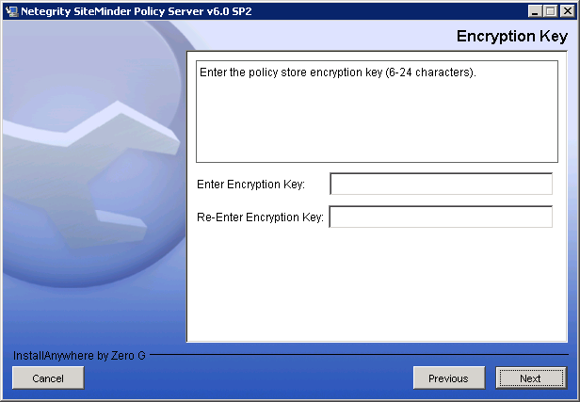
- Select the features to configure. The following features should be selected:
- OneView Monitor GUI
- Web Servers
- PolicyStore
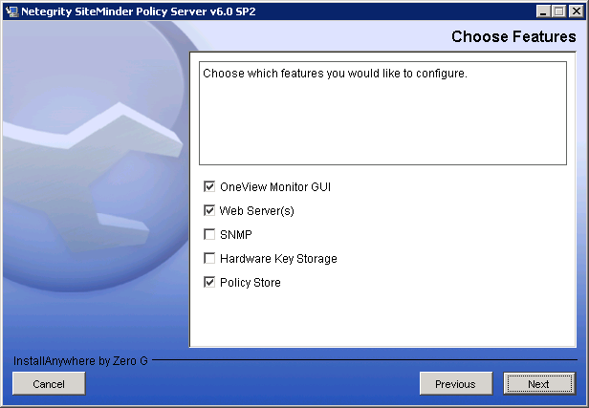
- Select the web server to configure. This will install the necessary components to run the OneView Monitor GUI (admin and configuration). By default the installer should find all supported web servers.
- Select “Other LDAP” server (if not using ADAM) and proceed to specify the server settings. You will need to specify an IP address, port number and root DN:
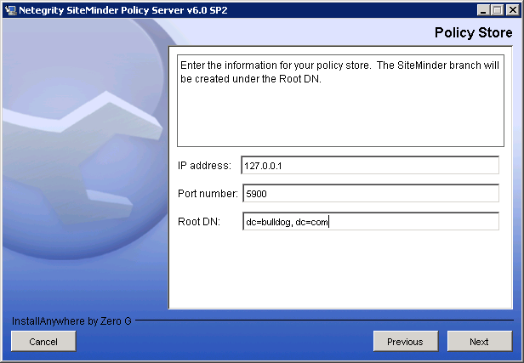
- Enter the Policy Store (LDAP) server administrator credentials:
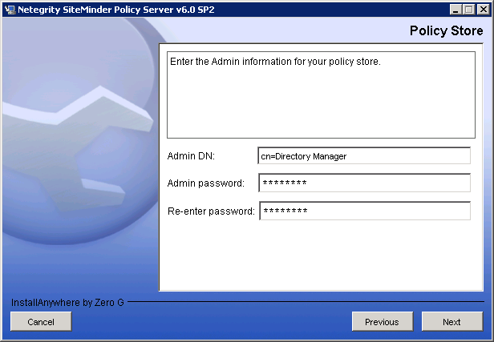
- Specify an alternate user to use for storing and managing the policy server settings in the LDAP server. Though this is not required, it is strongly recommended. The user will be created as part of the install process:
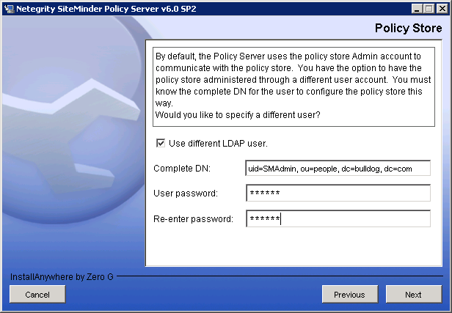
- On the next screen, be sure that “Initialize instance” is selected. This option will create and necessary configuration in the LDAP server.
- Enter the default password for the SiteMinder administrative user. The username, which is not displayed is SiteMinder.
- Finish the installation and restart the server

Configuring the Policy Server

The following steps are for a default installation of the policy server. For more advanced instances, such as configuring to use an LDAP server or Active Directory server as a user source, please see document Netegrity – Policy Design provided by Netegrity. In most cases, the user source does not matter for testing or debugging purposes. For trouble shooting tips with this kind of user source, please see below in the trouble shooting portion of this document.

Launching the Policy Server administrative interface
- Go to Start -> Programs -> Site Minder -> Netegrity Policy Server Interface
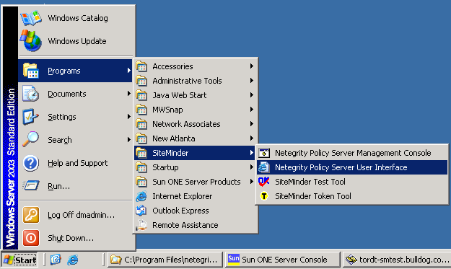
- This will launch your web browser and will connect to the local host web server which was configured by the installation program. Select the link to “Administer Policy Server”:
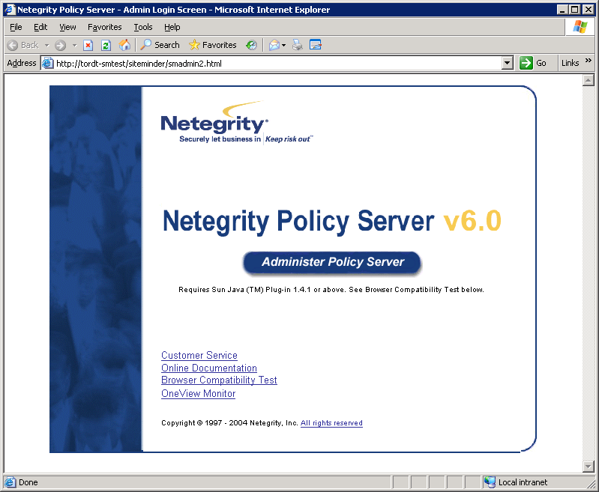
- Enter the username “SiteMinder” and the administrator password you configured during the installation:
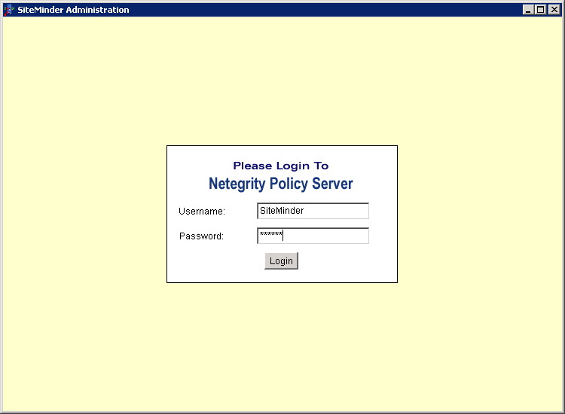
- Afterwards, you should see the following interface:
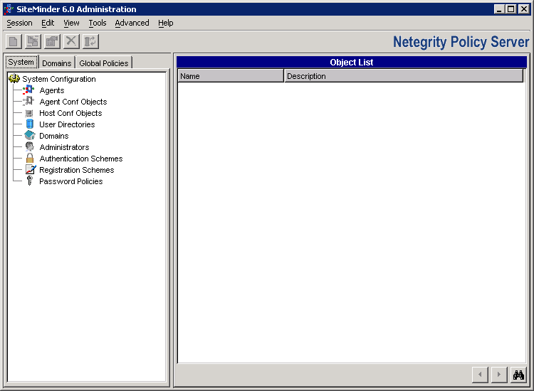

Configure an Agent Object
The first step is to configure an Agent Object. Though this document only configures the since Agent object, in several deployments it is common to have multiple Agents defined. In this setup the Agent will be used by both the web application to authenticate with as well as for the docbase to use. In some cases, clients have configured separate objects, one for each application that they wish to protect as well as another for the repository to use.

- In the main UI, select “Agents” from the tree on the left.
- In the right hand pane, right click and select the “Create New Agent” option.
- Configure the agent with an Agent Name.
- Select “Support 4.x Agents”. NB This is mandatory for the repository authentication plugin. If a separate agent will be used for protecting the web application, this option will not be needed. If “Support 4.x Agents” is selected, additional options will appear:
  - Enter the IP address of the policy server
  - Specify a “Shared Secret”. Remember this as it will be needed when configuring the authentication plugin.
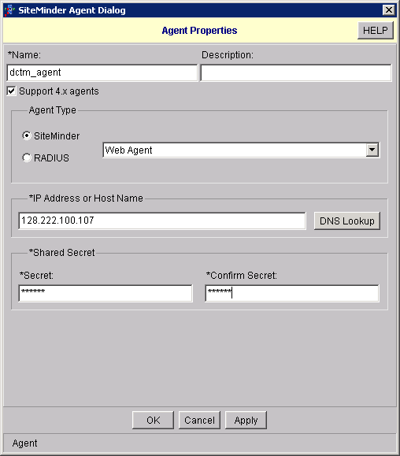
- Click “OK” to save this configuration.

Configure a “Host Configuration” Object
- From the main UI, in the left hand pane click on “Host Conf Objects”
- In the right hand pane, select the “DefaultHostSettings” entry, right click on it and select “Duplicate”
- Enter a new name for this object.
- Click on the “#PolicyServer” entry and select “Edit”
  - Uncomment the entry so that it reads “PolicyServer”
  - Enter the IP address of the policy server. NB This should not be 127.0.0.1, but an IP address that is routable from another machine.
- When finished the screen should look like this:
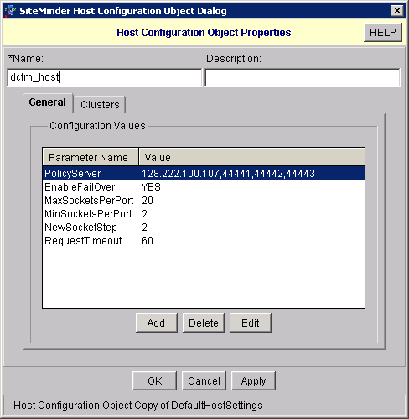

Create an “Agent Conf” Object
- From the main UI left hand pane, select “Agent Conf Objects”
- As per the Host Config object, duplicate one of the default Agent Conf objects based on the web server that will be used.
- Enter a unique name for this Agent Conf object.
- Uncomment the “DefaultAgentField” and enter the value of the name given to the agent above.
- Once done, the configuration should look like this:
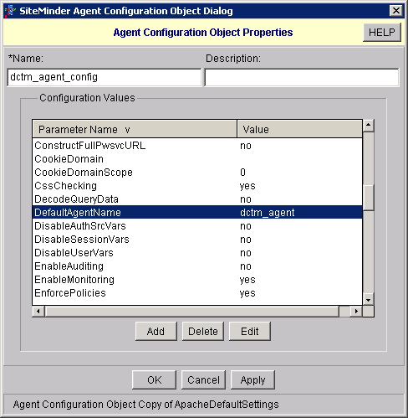

Protecting the Application

The above configuration is the basic Policy Server configuration. Once that is done it is necessary to specify the users and rules which will protect the web applications. To perform this step it will be necessary to specify:
- A user source
- A domain
- A realm
- Rules to apply
- A policy specifying which for which users the various rules created apply.

Create a User Directory
- Select “User Directories” from the left hand pane
- Right click in the right hand pane and create a new directory
- Assign a unique name to the user directory.
- For a basic domain:
  - Select “WinNT” for the namespace
  - Enter the fully qualified hostname of the local machine
  - To test, click on “View Contents”. You should see a list of Users and groups.
- When completed, the user directory should look like:
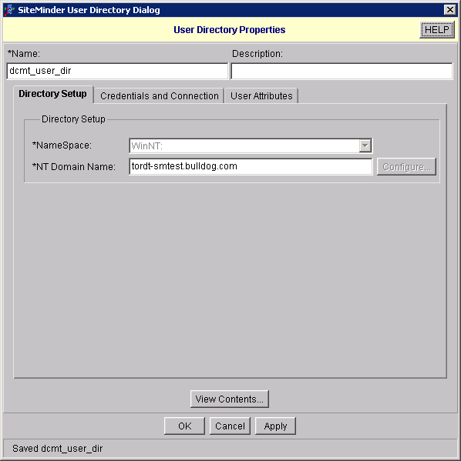

Create a Domain
- Click on the “Domain” tab. Right click and select “Create Domain”.
- Provide a unique name for the domain
- Select the user directory defined above and add it to the domain.
- When completed, the domain should look like:
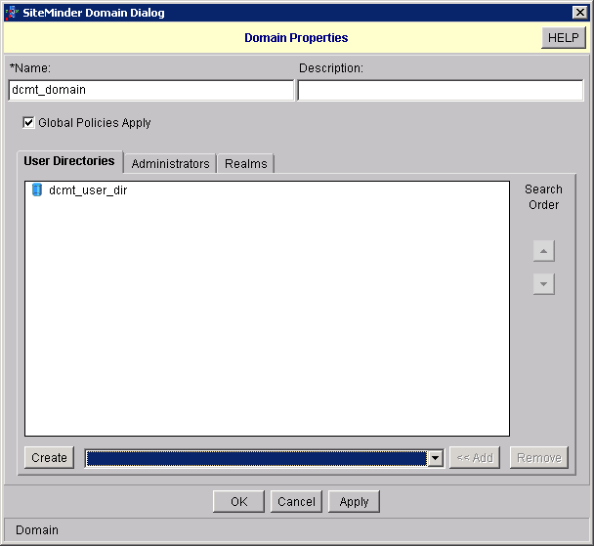

Create a Realm
- Expand the newly created domain
- Right click on “Realms” and select “Create Realm”
- Provide a new name for the realm
- Specify the Agent created above
- Specify “Basic” authentication
- Provide a Resource Filter. This is a basic URL pattern which will be protected. For a Webtop application, “/webtop” would be specified
- When finished it should look similar to:
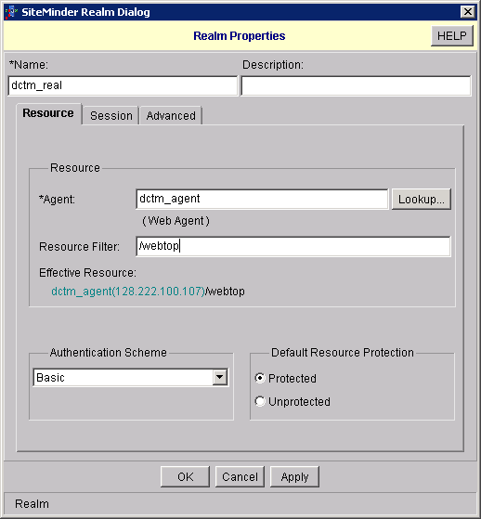

Create a Rule
- Expand the realm created, right click and choose “Create Rule”.
- Provide a unique name for the Rule
- Enter “*” as the resource filter for a WDK basked application. By default this field will be filled with “/*”.
- Select the actions “GET” and “POST”.
- When finished, it should look like:
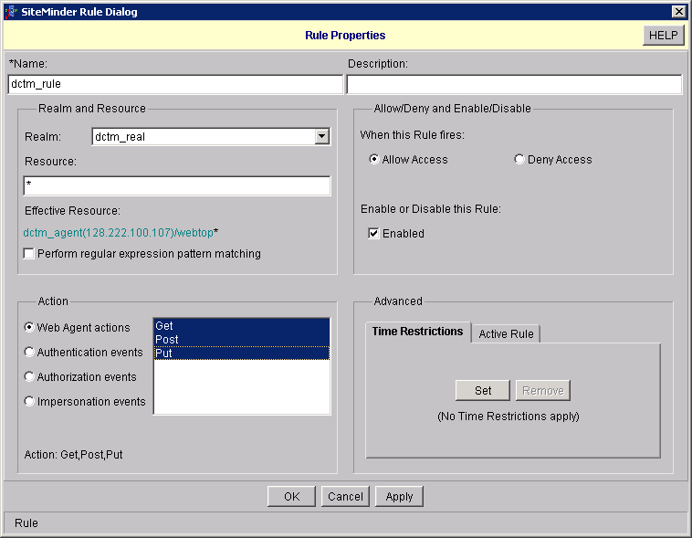

Create a Policy
- Under the domain created, select “Policies”. Right mouse click and select “New Policy”
- Provide a name.
- Select either the users which are able to authenticate and access the resource. These will be the users that will be allowed to log into the WDK application.
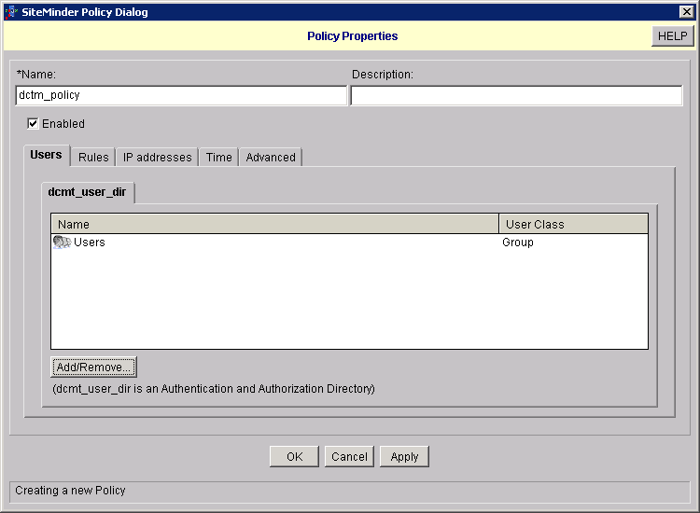
- Select the Rule tab.
- Add the rule created above to the policy.
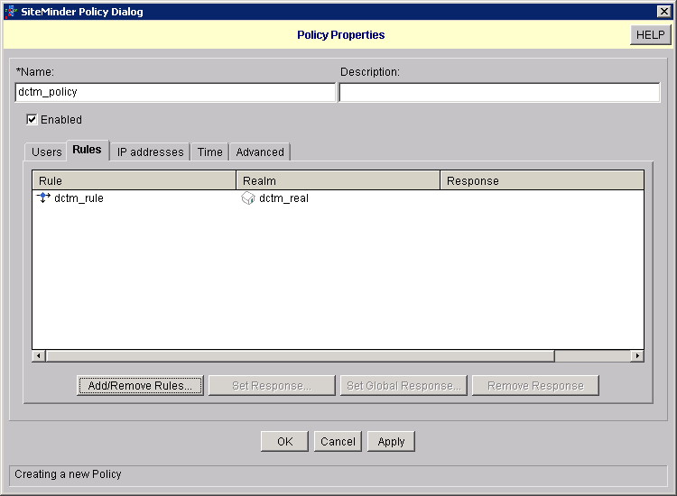
- Click OK to save

Final Steps
- As a final step, it would be wise to flush to cache. From the main interface select:
Tools -> Cache Management
- On the window opened, click on “Clear all Caches”.

Installing and configuring the web agents

The Web Agents (WA) portion of a SiteMinder deployment happens on the web server that acts as a proxy to the application server. The purpose of the WA component is to verify the desired resources are protected and that only authorized users have access to them. If a user is not authorized to access a protected resource, they will be directed to an HTTP 403 (Forbidden) error page. As of WDK release 5.3 SP2, Netegrity Web Agents 6.0 QMR 3 is supported.

As above, the ServletExec engine is needed if the self-registration option is to be enabled.

Running the Web Agent Installer

Please note – the same warning about DEP on Windows platforms also applies to the WA installer. Please see above for how to resolve this issue.

- Launch the WA installer
- Accept the license and specify the default locations for the Web Agents to be installed to.
- Let the installer run to completion.
- When prompted launch the WA Configuration utility. Alternately, launch this program at a later time to configure Web Agents on the web server.

Configuring Web Agents – WA Configuration program

- Run the WA Config program
- If you have not done so, select “Register Host” as the first option. NB – this only needs to be done once per installation.
  - Do not select to use PKS11 as this is not necessary in a testing environment
  - On the next screen enter the SiteMinder administrator username and password (default username is “SiteMinder”)
  - On the follow screen enter a unique name to register this host as, as well as the name of the Host Conf object defined above:
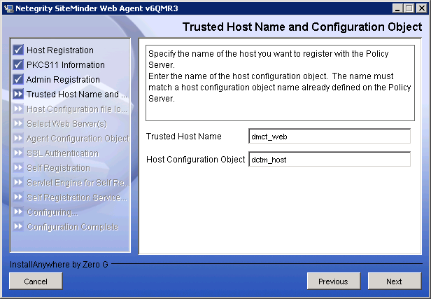
- On the following screen enter the IP address of the policy server. The Authentication Port need to be provide only if the default port is not being used (default is 44442).
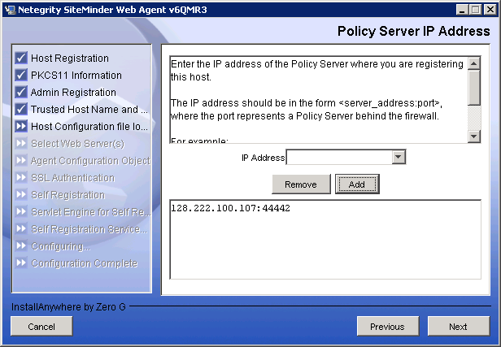
- Enter (or accept the default) location where the SMHost.conf file will be located. This is the global host configuration file for all of the agents defined for this installation.
- Click “Next” this will register the host and create the SmHost.conf file. The document “the Netegrity SiteMinder Web Agent Installation Guide” provides further information on this file and how to modify it.
- Select the web server to be configured for WA.
- On the following screens enter the Agent Conf object name defined above which will be used to configure this installation.
- When prompted, self registration can be enabled or not. If selected, ensure that the ServletExec product is installed as well.

Enabling the Web Agent

Once installed and configured, the agent and web server need to be configured to enable the web agent as well as to load the necessary libraries into the web server process so that the resources are protected. This process is different for each of the supported web servers. Below is detailed the process for configuring the Apache Web Server. Instructions to configure other servers can be found in the Netegriy Web Agent Installation Guide. There are two steps to the process; the first is to enable the web agent and the second is to configure the web server.

To Enable the Web Agent
- Edit the file <apache_home>/conf/WebAgent.conf
- Set EnableWebAgent to Yes.
- Save and close the file.

Modifying the httpd.conf File
- Edit the file <apache_home>/conf/httpd.conf
- Specify the library path to be used by the Apache web server
  - Find the Global Environment section of the file
  - Add the line:
PassEnv LD_LIBRARY_PATH <web_agent_home>/bin
where <web_agent_home> is the install location for WA.
  - Alternately you can modify the user environment (via .bashrc or cshrc) and export the above LD_LIBRARY_PATH
- Add the following to the Dynamic Shared Object (DSO) Support part of the httpd.conf file where <libexec_path> is the full path to <wa_install>/bin.
  - For Unix: LoadModule sm_module <libexec_path>/mod2_sm.so
  - For Windows: LoadModule sm_module <libexec_path>/Apache20WebAgent.dll
- If the directive ClearModuleList exists in the DSO configuration section, add mod_sm.c to the end of the AddModule section of the file, shown in bold:
ClearModuleList
AddModule mod_env.c
...
AddModule mod_servletexec.c
#Siteminder
AddModule mod_sm.c
- In the Main server section of the file, file, add the SmInitFile entry after the LoadModule entry. The full path to the init file will need to be used:
SmInitFile <Apache_home>/conf/WebAgent.conf
- Add the following to the Aliases section of the httpd.conf file. NB – these should be added to the end of the aliases section and absolute paths need to be used:

#Password Services
Alias /siteminderagent/pwcgi/ “<web_agent_home>/pw/”
<Directory "/export/webagent/pw/">
Options Indexes MultiViews ExecCGI
AllowOverride None
Order allow,deny
Allow from all
</Directory>
Alias /siteminderagent/pw/ “<web_agent_home>/pw/”
<Directory "/export/webagent/pw/">
Options Indexes MultiViews ExecCGI
AllowOverride None
Order allow,deny
Allow from all
</Directory>

#Basic over SSL authentication
AliasMatch /siteminderagent/nocert/[0-9]+/(.*)
"<web_agent_home>/$1"
<Directory "/export/webagent/samples/">
Options Indexes MultiViews
AllowOverride None
Order allow,deny
Allow from all
</Directory>
# Forms authentication or Agent is cookie provider for single sign-on
Alias /siteminderagent/ “<web_agent_home>/samples/”
<Directory "/export/webagent/samples/">
Options Indexes MultiViews
AllowOverride None
Order allow,deny
Allow from all
</Directory>
- In the AddHandler section, the following entries need to be added.
AddHandler cgi-script .exe
AddHandler smformsauth-handler .fcc
Other features are detailed on pg. 87 of the WA installation guide.
- Save the httpd.conf file and restart the Apache Web Server

IMPORTANT - Tuning Shared Memory on Solaris or HP-UX Systems
If the Web Agents are being installed on a Unix system, additional steps are needed to tune the memory. The steps for Solaris are provided below. A complete explanation can be found on pg. 104 of the Web Agents Installation Guide. NB – this step is not necessary for Linux, Windows or AIX systems.
- Edit the file /etc/system
- Add the following entries below (suggested minimum valules)
set shmsys:shminfo_shmmax=33554432
set semsys:seminfo_semmni=100
set semsys:seminfo_semmns=100
set semsys:seminfo_semmnu=200
set shmsys:shminfo_shmseg=24
- Save and exit the file
- Reboot the system
- Verify the settings by running “sysdef –i”

Configuring Documentum to use Siteminder

To configure Documentum to use SiteMinder, there are 2 distinct portions:
- Configure the WDK application to retrieve the SiteMinder credentials from the request
- Configure the repository to validate the authentication token against the policy server.

Configuring WDK Applications

For WDK applications that are protected by SiteMinder the following workflow applies:

- A request comes into the web server serving as a proxy for the application server.
- The Web Server detects that it is a request for a SiteMinder Protected Resource
- If the SiteMinder authentication token is not present, the Web Agent redirects the user to the appropriate authentication mechanism.
- Once authenticated, the WA verifies that the user can access the resource according to the defined policy.
- If allowed, the request is forwarded to the application server.
- The WDK application retrieves the SiteMinder user name as well as the authentication token.
- The WDK application tries to log the user into the repository using these values.
- The repostiroy verifies that the user is one who’s source is dm_netegrity, if so it will verify the token and user name.

To enable this on the WDK application, the following must be done:
- The file wdk/app.xml must be editied. Under <authentication> the following values will need to be added:
<authentication>
<domain/>
<docbase>sm_docbase</docbase>
<service_class>
com.documentum.web.formext.session.AuthenticationService
</service_class>
<sso_config>
<ecs_plug_in>dm_netegrity</ecs_plug_in>
<ticket_cookie>SMSESSION</ticket_cookie>
<user_header>SM-USER</user_header>
</sso_config>
</authentication>
- Restart the application server.

Configuring the Repository
Documentum provides a plugin which allows the repository to verify a user’s credentials against a policy server. It will take a user name and a generated authentication token and query the policy server to see if it is valid. If it is, the user can access the repository. By default this plugin is not enabled. All of the required files can be found under: $DM_HOME/install/external_apps/authplugins/netegrity

To enable the plugin:
- Copy the file $DM_HOME/install/external_apps/authplugins/netegrity/dm_netegrity_auth.so (or dll if on windows) to $DOCUMENTUM/dba/auth
- Copy the file dm_netegrity_auth.ini to the same location.
- Copy the supporting library $DM_HOME/install/external_apps/authplugins/netegrity/SmAgentAPI.so (or .dll if windows) to $DM_HOME/bin.
- Edit the dm_netegrity_auth.ini file under $DOCUMENTUM/dba/auth and enter the values from the policy server configuration steps. A sample of the file is provided below:

#This is a sample configuration file for the Documentum/Netegrity plugin

[DM_NETEGRITY_AUTH_CONF]
#name of the agent protecting the Documentum web application
#this is a mandatory parameter
agent_name=dctm_agent

#shared secret between the Netegrity Web Agent and Policy Server
#this is a mandatory parameter
shared_secret=r1ng3r

#IP address of Netegrity Policy Server. For failover and load balancing,
#you can specify more than one, in which case they must be separated by
#commas. No spaces are allowed.
#this is a mandatory parameter
policy_server_ip=128.222.100.137

#Netegrity Policy Server accounting port
#Defaults to 44441
#accounting_port=44441

#Netegrity Policy Server authentication port
#Defaults to 44442
#authentication_port=44442

#Netegrity Policy Server authorization port
#Defaults to 44443
#authorization_port=44443

#Failover mode. This is used if more than one Policy Server
#is specified in policy_server_ip. Supported values are 0 and 1.
#Defaults to 0. Refer to Netegrity documentation for details.
failover_mode=0

- Restart the repository. Verify that the plugin is loaded by viewing the server log file, there should be a [DM_NETEGRITY_AUTH_PLUGIN_LOADED] entry.

Troubleshooting

Logging

There are several forms of logging available to help diagnose problems with the integration with SiteMinder. Logging can be enabled for the following parts of the deployment:
- The Content server and the authentication plugin
- Web agent transactions
- Policy server

Content Server Logging & the Login Sequence

By default, logging can be enabled on the Content Server to help diagnose issues with the SiteMinder plugin. To enable the tracing, the following option needs to be passed to the content server on startup ‘-otrace_authentication’. This option will have two effects:
- All authentication calls will be logged in the content server log as well as the response (success or failure).
- A second log file (dm_netegrity.log) will be generated in the logs directory as well. This log file is the result of debugging added to the Netegrity authentication plugin and may contain Netegrity specific errors (e.g. “cannot connect to policy server”).

When an application tries to authenticate a user against a SiteMinder deployment, the connect statement generated will be of the form:

connect,<docbase>,<user>,DM_PLUGIN=dm_netegrity….

where <…> is the encoded SMSESSION cookie.

When the content server receives such an authentication request, the content server first examines the user_source attribute on the user mentioned. If the user_source attribute is set to be “dm_netegrity”, then the Netegrity plugin will be used to authenticate the user. The authentication plugin will extract the authentication credentials from the SMSESSION cookie passed and validate it against the policy server. The plugin will also verify that either the user_name, user_os_name or user_ldap_dn of the user provided matches the distinguished name that was decoded from the cookie.

Web Agent logging

If the Web Agent fails to launch or if it encounters a fatal error, it will log using the normal system logging facilities. This means that on Windows it will log to the Event Viewer (under Application) and on Unix it will log to STDERR.

The Web Agents also have two additional forms of logging; they are:
- Error Logging for operational and program errors (e.g. unable to connect to policy server)
- Trace Logging which is a detailed log file of warning and informational messages. The granularity of the logging can be configured.

To enable Error Logging in the Agent Config Object set the following:
- The LogFile parameter to Yes
- Set the value for LogFileName to be the full path to the log file on the web server where the agent is deployed.
- You can also set these optional parameters:
- LogAppend – Yes to append to the existing log, no to overwrite each time the agent is restarted
- LogFileSize – Max size in MB for the file size after which the log file will be rolled over
- LogLocalTime – Yes if log entries should be time stamped with the server local time. No will result in timestamps using GMT

To enable the Trace log, two things must be configured:
- The Trace configuration file (WebAgentTrace.conf) which determines which components will be logged and at what level.
- The Agent Config object to enable tracing and to specify the location of the trace file.

To modify the Web Agent Config object:
- Set TraceFile to Yes
- Specify the full path to the trace file (on the server with the web agent) for the parameter TraceFileName.
- Specify the full path (on the web agent server) to the WebAgentTrace.conf file for the parameter TraceConfigFile.
- Specify the format for the trace file. Parameters responsible for this are:
- TraceAppend – Yes indicates that the file will not be overwritten
- TraceFormat – The format of the trace file. The options are:
  - fixed - fields with a fixed-width
  - delim - fields delimited by a user-specified character
  - xml - fields and messages enclosed in XML-like tags. There is no DTD or style sheet provided with the Web Agent.
  - default - fields enclosed in square brackets

The next step is to modify the WebAgentTrace.conf file. A sample of a file would look like:

components: WebAgent
data: Date,Time,IPAddr,Resource,Action,Message
Resource:==/html
Domain:==netegrity.com

This configuration will only log Web Agent messages for access to html file resources for the netegrity.com domain. Each message would include the date, time, IP address of the browser, the resource being accessed, the action against that resource, and the log message.

Please note that this is a case sensitive configuration file. Comment lines (beginning with #) will be ignored.

The values for components, data, Resources and Domain must be specified.

The values available for components are:
- AgentFramework – All Agent framework messages (IIS 6 ONLY).
- AffiliateAgent – Messages for the 4.x affiliate agent (IIS 6 ONLY).
- SAMLAgent – Messages for the SAML Web Agent (IIS 6 ONLY).
- HTTPAgent – Messages for the HTTP Web Agent (IIS 6 ONLY).
- WebAgent – All WebAgent messages (For all web server EXCEPT IIS 6).
- AgentFunc – All Agent API messages.

Example: componets: WebAgent,AgentFunc

If you don’t need to log all the messages for a particular agent, you can specify the sub-components that are of interest. E.g. components: WebAgent/SSO

A full list of the available sub-components are:

AgentFramework | - Administration  - Filter  - HighLevelAgent  - LowLevelAgent  - LowLevelAgentWP
AffiliateAgent | - RequestProcessing
SAMLAgent | - RequestProcessing
HTTPAgent | - AdvancedAuthentication  - RequestProcessing  - SingleSignOn
WebAgent | - AgentCore  - Cache  - authentication  - Responses  - Management  - SSO  - Filter

The syntax for specifying data fields is:
data:<data_field1>,<data_field2>,<data_field3>

The available data fields for all components are:
- Message - The actual trace message
- SrcFile - The source file and line number of the trace message
- Pid - The process ID
- Tid - The thread ID
- Date - The date
- Time - The time
- PreciseTime - The time, including milliseconds
- Function - The function in the code containing the trace message
- User - The name of the user
- Domain - The SiteMinder domain
- Realm - The SiteMinder realm
- AgentName - The Agent name being used
- TransactionID - The transaction ID
- DomainOID - The SiteMinder domain OID
- IPAddr - The client IP address
- IPPort - The client IP port
- CertSerial - The certificate serial number
- SubjectDN - The subject DN of the certificate
- IssuerDN - The Issuer DN of the certificate
- SessionSpec - The SiteMinder session spec
- SessionID - The SiteMinder session ID
- UserDN - The User DN
- Resource - The requested resource
- Action - The requested action
- RealmOID - The realm OID

To better focus on a specific problem, you can narrow the output of the trace log by specifying a filter based on the value of a data field. For example, if you are having problems with an index.html page, you can filter on resources with an html suffix by specifying Resource:==/html in the trace configuration file. The syntax for a filter is: <data_field>:<filter>

N.B. Each filter should be on a separate line in the file.

Examples:
Action:!=get
Resource:==/html

The Boolean values available are exact match (==) or not equals (!=).

Policy Server Logging

Though it may not be often needed – logging can be enabled on the policy server itself. To enable logging, the Management Console (NOT the configuration web app) must be used. To enable logging, launch the Management Console and select the “Logging” tab. Here you can specify the location of the log file as well as for which event logging should be enabled. The available events are:
- Authentication Events
- Authorization Events
- Affiliate Events
- Administrator Access Events
- Administrator Changes to Policy Store Objects.

Other Resources

As always, the vendor documentation should be considered a primary source of additional information. The relevant documents are:

- Netegrity – Policy Design Guide
- Netegrity Policy Server Installation Guide
- Netegrity Web Agents Installation Guide

Downloads of these documents as well as support forums are available at http://support.netegrity.com

Support Site Login: sherri.pevear@documentum.com
Customer ID: 286980
Password: pinkdoll87

